R PROGRAMMING

P.Manohar

ASSESSEMENT DAY-1 192110379

1.Write a R program to create a vector of a specified type and length. Create vector of numeric, complex, logical and character types of length 6 with your own examples. print the vector, type, and length. Use this vector for Below program

x = c(10, 20, 30, 20, 20, 25, 9, 26,38,40)

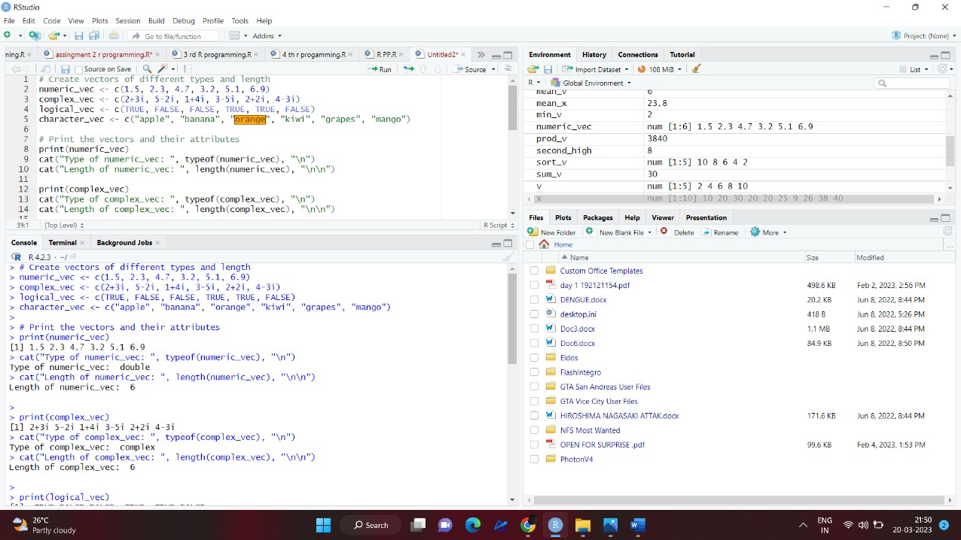

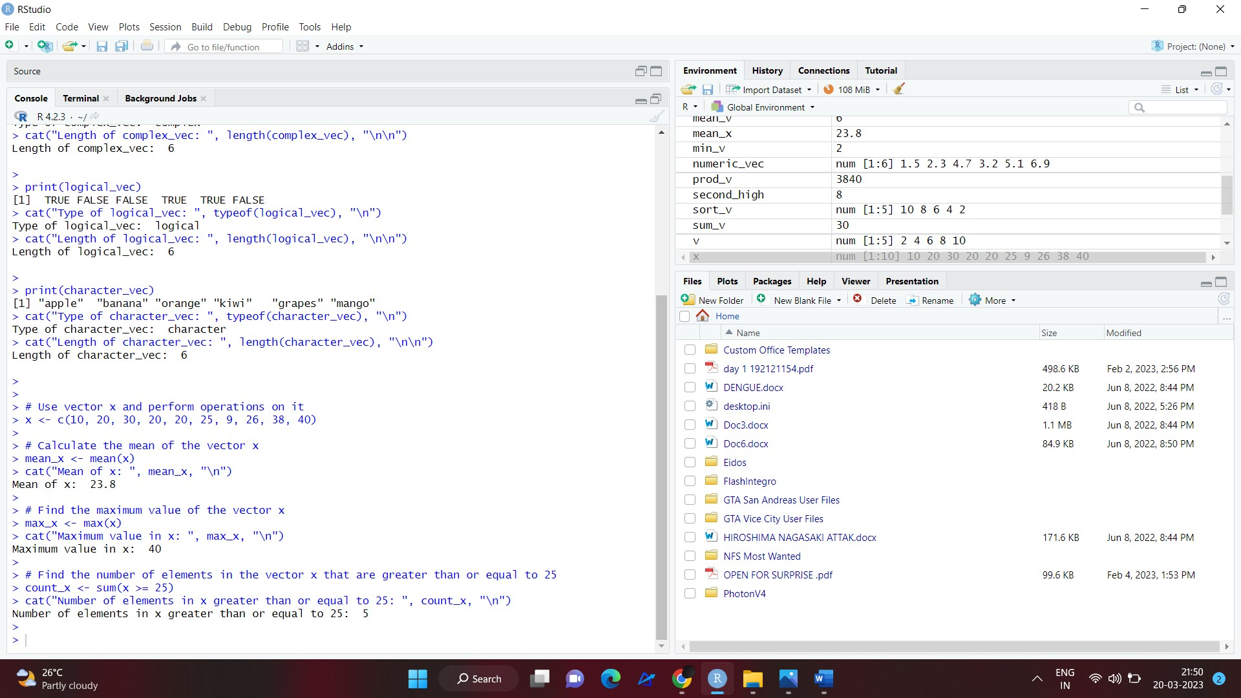

2. Write a R program to find Sum, Mean and Product of a Vector. 3.

Write a R program to find the minimum and the maximum of a Vector 4.

Write a R program to find second highest value in a given vector.

Write a R program to find Sum, Mean and Product of a Vector. 3.

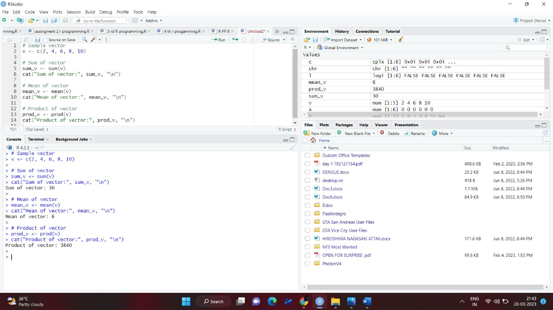

Write a R program to find the minimum and the maximum of a Vector 4.

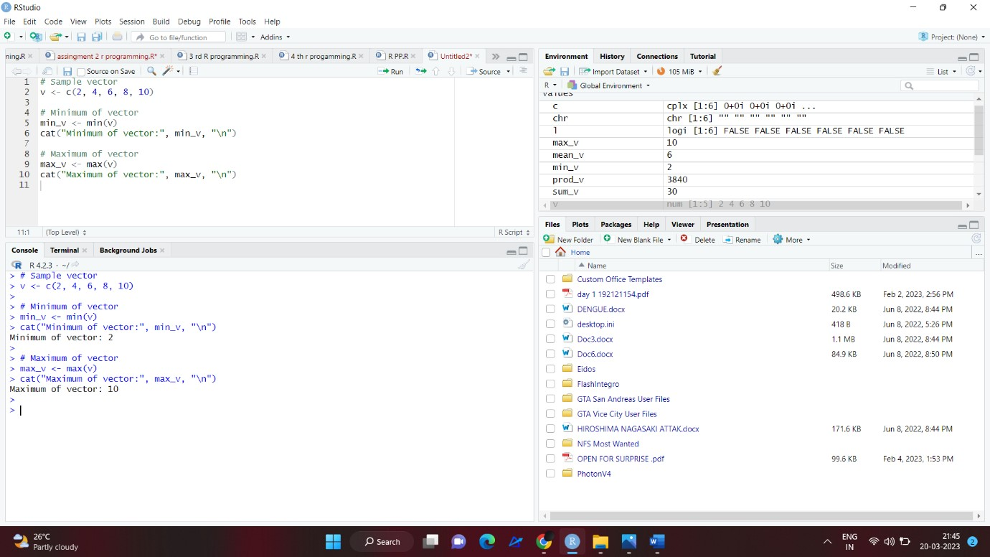

Write a R program to find second highest value in a given vector

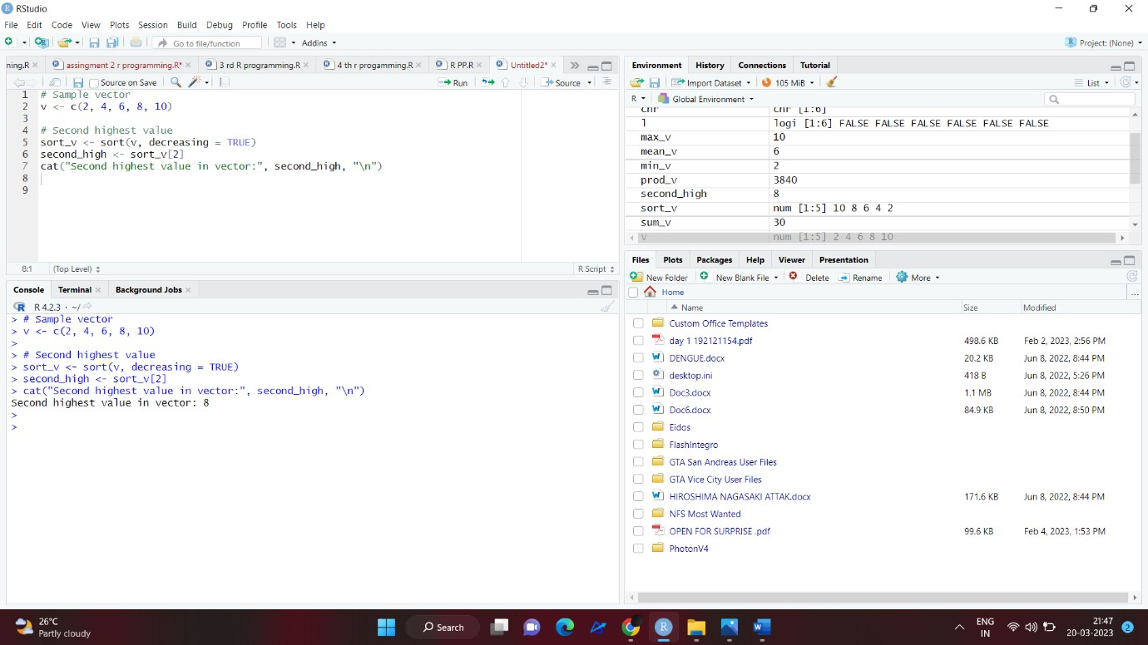

1. Write a R program to add a new item g4 = &quot;C++&quot; to a given list.

Sample list: (g1 = 5:10, g2 = &quot;R Programming&quot;, g3 = &quot;HTML&quot;).

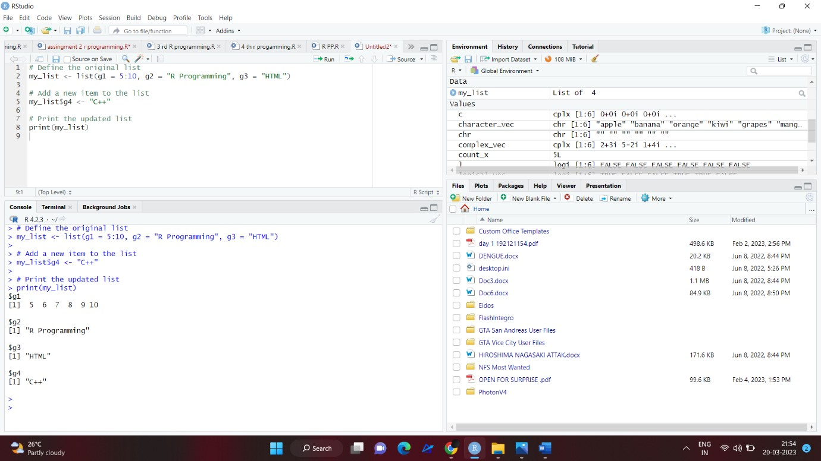

1. Write a R program to extract all elements except the third element of thefirst vector of a given list.

Sample list: (g1 = 5:10, g2 = &quot;R Programming&quot;, g3 = &quot;HTML&quot;)

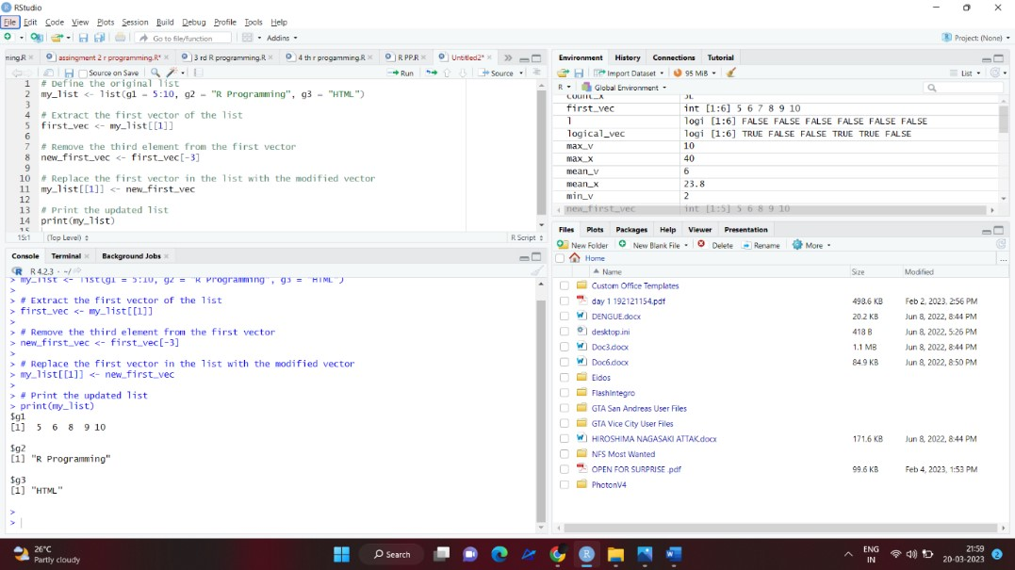

1. Write a R program to create an ordered factor from data consisting of the

names of months .

